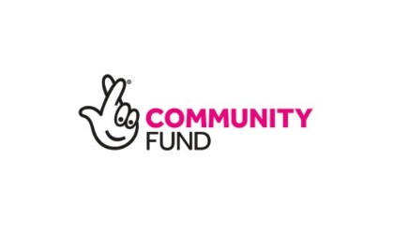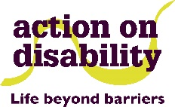**Our Place Activities Timetable September 2024**

Here are the list of activities happening as part of the Our Place Project for the month of October. If you wish to join, please contact:

Terry: [Terence.King@aod.org.uk](mailto:Terence.King@aod.org.uk) or Call 07776512816

Reception: [Info@aod.org.uk](mailto:Info@aod.org.uk) or Call 020 7385 2098

We look forward to seeing you soon!

|  |  |  |
| --- | --- | --- |
|  | **Activity** | **Time** |
| **Monday – September 30th** | Yoga    Art Group | 1 pm – 2 pm    2:30 pm – 4:30 pm |
| **Tuesday – October 1st** | Gardening Group (AoD Offices)  Crafts Club | 11 am – 1 pm  1:30 pm – 3:30 pm |
| **Wednesday – October 2nd** | Writing for Wellbeing (Online) | 2 pm – 4 pm |
| **Thursday – October 3rd** | Let’s Play Pool | 1 pm – 3 pm |
| **Friday – October 4th** | Coffee Morning  The New Normal (Facilitator Training) **Fully Booked** | 10 am – 12 pm  12 pm – 1:30 pm |
| **Monday – October 7th** | Yoga    Art Group | 1 pm – 2 pm    2:30 pm – 4:30 pm |
| **Tuesday – October 8th** | Gardening Group  Crafts Club  NHS Back on Track (Online & In-Person) – **Please contact to book** | 11 am – 1 pm  1:30 pm – 3:30 pm  2:30 pm – 3:30 pm |
| **Wednesday – October 9th** | Writing for Wellbeing  Next Steps (18-30) | 11 am – 1 pm  1 pm – 3 pm |
| **Thursday – October 10th** | Let’s Play Pool  Visual Impairment/Sight Loss Group | 1 pm – 3 pm  6 pm – 8 pm |
| **Friday October 11th** | Coffee Morning    The New Normal (Facilitator Training) – **Fully Booked**  Steering Board (Invitation Only) | 10 am – 12 pm    12 pm – 1:30 pm      2 pm – 4 pm |
| **Monday – October 14th** | Yoga    Art Group | 1 pm - 2 pm    2:30 pm – 4:30 pm |
| **Tuesday – October 15th** | Gardening Group (AoD Offices)    AoD Crafts Club | 11 am – 1 pm    1:30 pm – 3:30 pm |
| **Wednesday – October 16th** | Next Steps (18-30)  Writing for Wellbeing (Online) | 1 pm – 3 pm  2 pm – 4 pm |
| **Thursday – October 17th** | Let’s Play Pool | 1 pm – 3 pm |
| **Friday October 18th** | Coffee Morning    Facilitator Training (joined by The New Normal – **Fully Booked** | 10 am – 12 pm    12 pm – 1:30 pm |
| **Saturday – October 19th** | West London Deaf Club | 4:30 pm – 9:30 pm |
| **Monday – October 21st** | Yoga  Art Group | 1 pm – 2:pm  2:30 pm – 4:30 pm |
| **Tuesday – October 22nd** | Gardening Group (AoD Offices)    AoD Crafts Club | 11 am – 1 pm  1:30 pm – 3:30 pm |
| **Wednesday – October 23rd** | Writing for Wellbeing  Next Steps | 11 am – 1 pm  1 pm – 3 pm |
| **Thursday – October 24th** | Let’s Play Pool  LGBTQ + Group | 1 pm – 3 pm  5:30 pm – 7:30 pm |
| **Friday – October 25th** | Our Coffee Morning | 10 am – 12 pm |
| **Monday – October 28th** | Yoga  Art Group | 1 pm – 2 pm    2: 30 pm – 4:30 pm |
|  |  |  |
| **Tuesday – October 29th** | Gardening Group  Crafts Club | 11 am – 1 pm  1:30 pm – 3:30 pm |
|  |  |  |
| **Wednesday – October 30th** | Next Steps 18 – 30  Writing for Wellbeing (Online) | 1 pm – 3 pm  2 pm – 4 pm |
|  |  |  |
|  |  |  |
| **Thursday October 31st** | Let’s Play Pool | 1 pm – 3 pm |